

GOVERNMENT ARTS AND SCIENCE COLLEGE,
PERUMBAKKAM, CHENNAI-131

INTERNAL QUALITY ASSURANCE CELL
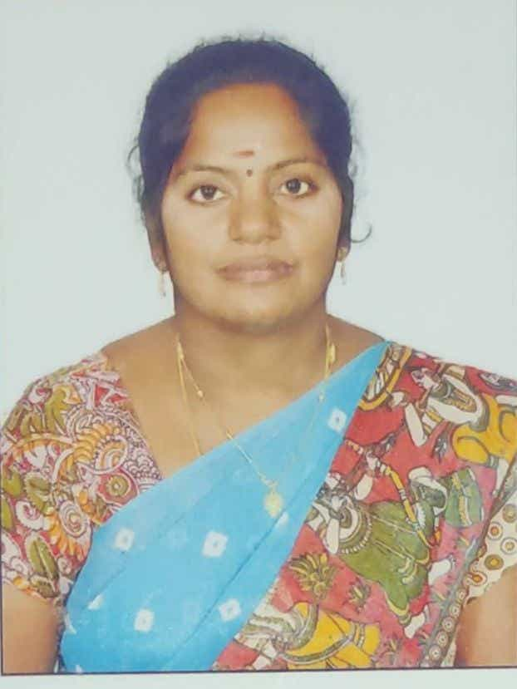

STAFF PROFILE REPORT

- GENERAL INFORMATION

a) Name and Designation : Dr.V.RAJAM

b) Department : Mathematics

c) Date of Joining : 26.12.2007
(Govt. Service)

d) Age and Date of Birth : 05.10.1976

e) Aadhar No. : 209221000203

f) PAN No. : AOWPR1507D

g) Address for communication : 2/227,Bhaktha Reddy avenue,
BHEL Nagar,
Vadakkupattu main road,
Medavakkam,
Chenna -600100.

h) Permanent address : 157,Arulananathammal Nagar,
9th cross,
Thanjavur -613007.

i)Contact Number : 9442515369

j) Email id : rajamramv@gmail.com

- ACADEMIC BACKGROUND

i) Academic Qualifications

Exam passed | Subjects/  Programme | College/  School Name | Board / University | Month & Year of Passing | Percentage | Division/ Grade/
Post-Doctoral | - | - | - | - | - | -
Ph.D | Mathematics | Rajah serfoji Govt.college,Thanjavur. | Bharathidasan University,Thiruchirappalli | November 2024 | Highly commented | -
M.Phil | Mathematics | Govt.arts college,  Kumbakonam. | Bharathidasan University,Thiruchirappalli | Sep’ 2002 | 96.02 | -
PG | Mathematics | Govt.arts college,  Kumbakonam | Bharathidasan University,Thiruchirappalli | April 2000 | 84.76 | -
UG -- | Mathematics | S.K.S.S.Arts college,Thiruppanandal. | Bharathidasan University,Thiruchirappalli | April 1997 | 58.62
Any other | - | - | - | - | - | -
HSC | Bio.Maths | S.K.G.S.Hr.sec.school,Thirupanandal | State board | April 1994 | 66.5
SSLC | Mathematics, | S.K.G.S.Hr.sec.school,Thirupanandal | State board | April 1992 | 56.6

ii) Research Experience & Training

Research stage | Year of Registration | Title of work / Thesis | University where the work was Carried out | Year of Award
M.Phil or equivalent | 2000 | Nichi Graph – The ecological graph | Bharathidasan University,Thiruchirappalli | Sep’ 2002
Ph.D. | 2014 | Neutrosophic Algebra | Bharathidasan University,Thiruchirappalli | Nov’2024
Post - Doctoral | - | - | - | -

iii) Professional Excellency summary (after entry to Govt. College)

Courses Taught | Name of the University/  College/ | Duration | Date  (From …..To) | Experience  in Govt. Service | Experience  Other than Govt. Service | Total Experience
i)UG | M.R.Arts and science college,Thathanur.  PRIST University  Govt.college for women,kumbakonam.  Rajah serfoji Govt.college,Thanjavur.  Govt.Arts and Science college,Perumbakam. | 3 Yrs 6 months  2yrs 6 months  7yrs 10months  10yrs 4months  1yr 2months | 05.09.2001 to 24.05.2005  10.07.2005 to 11.0702007  26.12.2007 to  14.09.2014  15.09.2014 to 05.12.2024  06.12.2024 to till date | 19yrs 2months | 6yrs 6months | 25yrs 8 months
ii)PG | M.R.Arts and science college,Thathanur.  PRIST University  Govt.college for women,kumbakonam.  Rajah serfoji Govt.college,Thanjavur.  Govt.Arts and Science college,Perumbakam. | 2 Yrs 6 months  2yrs 6 months  7yrs 10months  10yrs 4months  1yr 2months | 05.09.2001 to 24.05.2007  10.07.2005 to 11.0702007  26.12.2007 to  14.09.2014  15.09.2014 to 05.12.2024  06.12.2024 to till date | 19yrs 2months | 6yrs 6months | 25yrs 8 months
iii)M.Phil | PRIST University  Rajah serfoji Govt.college,Thanjavur. | 2yrs 6 months  10yrs 4months | 10.07.2005 to 11.0702007  15.09.2014 to 05.12.2024 | 10yrs 4months | 2yrs 6 months | 12yrs 10months
iv)Any other | - | - | - | - | - | -

C) ACTIVITIES OF THE FACULTY MEMBERS

- Awards/Recognition received by the faculty : NIL
S. No | Year | Category | Date | Name of the award | Nature of the award medal/certificate/cash prize | Name of the Awarding Agency with Address & Contact Details | Level

- Member in Academic council/BOS/Professional Organisation: NIL

S. No | Year | Nature of Role | Duration | Date  ( From…. To) | Name of the Univ/College/ Organisation | Level

- Participation as resource person/inspection commission member/ Chief guest/ any other: NIL

S.No | Year | Nature of participation | Title of the Programme | Date | Name of the Institution /University/organization attended | Level

- Member/Panel of examiners

S. No | Year | Name of the University /College | Position | Duration | Date  (From…. To)
1 | 2010 | Bharathidasan University,thiruchirappalli. | Internal & external examiner(valuation,practical) UG &PG Board.  UG &PG Chief examiner | 24 yrs 6 months | 20.05.2010 to 28.11.2024

- Membership in Professional Bodies:NIL

S.No | Year | Name of the  Professional body | Membership No | Nature of Membership | Duration | Date  (From…. To) | Level

- Member of Editorial board (Journals/Books) : NIL
S.No | Year | Name of the Journal/Book | Position | Duration | Level

- Seminars/Workshop/Symposium/Hands on training (Organised)
S.No | Year | Programme Type | Position | Name of the Programme | Name of the Institute/University/  organization | Duration | Date  (From…. To) | Level
1 | 2013 | UGC Auto grand - sponsored Workshop | Organizer | Mathematical modelling in biology using SPSS | G.A.W.C.Kumbakonam | 2 days | 18th&19th oct’2013
2 | 2008 | workshop | organizer | Interview skills | G.A.W.C.Kumbakonam | 2 days | 16th &17th oct’2008
3 | 2009 | UGC sponsored National seminar | organizer | Recent advancement in mathematics | G.A.W.C.Kumbakonam | 2 days | 21st &22nd dec’2009
4 | 2009 | Training cum orientation  For item preparation on test and evaluation | participation | National testing service -India | National college ,Thiruchirappalli. | 3 days | 30.09.2009 to 02.10.2009
5 | 2009 | Training cum orientation  For item preparation on test and evaluation | participation | National testing service -India | National college ,Thiruchirappalli | 3 days | 28.05.2009 to 30.05.2009

- Participation in workshops/conference/symposium/seminar

S.No | Year | Category | Title of the sym/workshop/sem/  conf | Name of the College / University | Duration | Date  (From…. To) | Participation/  Presentation (Paper or Poster) | Title of the paper | Level
- RESEARCH DETAILS : Research Supervisor
S.No | Year | Name of the red | Date of Recognition | Area of Specialisation | Remarks

- Details of M.Phil Guided & Guiding
S.No | Month & Year of Registration | - University under which guided/ guiding | Area of Specialisation | Nature of Registration | No of candidates &Name of the Scholar | Title of the dissertation | Status Completed/  ongoing
1 | April2006 | Bharathidasan University, Tiruchirappalli | Stochastic Processes Algebra | Research advisor |  |  | 18 completed

- List of PG Students Guided
S.No | Year | University under which guided | No of candidates guided | Area of Specialization | Status Completed/  ongoing
1 | 2005 – till date | Bharathidasan University ,Tiruchirappalli | 98 | Stochastic processes, algebra, numerical methods, fuzzy graph, OR | Completed and ongoing

S.No | Batch | Register No | Name of the College | Name of the Student | Title of the dissertation | University under which guided | Status &  Date of completion
- Research projects undertaken
S.No | Year& Date of Sanction | Type of Project | Duration of the project | Title of the project | Funding agency | Fund Sanctioned | Status  Completed/ongoing

- Patent details
S.No | Year | Patent Title | Type | Patent No.

- Publication of research articles/ abstracts in seminar/ conference proceedings
S.No | Year | Title of the sem/ conf | Level of Publication  National/ International | Name of the Journal | Title of the article/  Abstract | Details of publisher | Month & Year of Publication | ISSN/ISBN  No. | Citation index/  impact  factor

- Publication in Journals
S.No | Year | Name of the Journal | Level of Publication  National/ International | UGC Listed Journal | Title of the Paper | Month & Year of Publication | ISSN/ISBN  No. | Citation index/  impact factor | Print/online
1 | 2015 | The mathematical science international research journal | International | UGC-CARE list group B | Analysis of M^{[x]} /G(m)/1 queue with service interruption and generalize server vacation. | April 2015 | 26-28 | - | Online
2  3  4  5  6  7  8  9  10  11 | 2019  2019  2021  2021  2021  2021  2024  2024  2025  2025 | Journal of computer and mathematical science  Malaya journal of matematik  Turkish journal of computer and mathematics education, Vol 12  Turkish journal of computer and mathematics education, Vol 12  Stochastic modelling and applications vol25  Stochastic modelling and applications vol25  International journal of Neutrosophic science  International journal of Neutrosophic science  International journal of Neutrosophic science  International journal of Neutrosophic science | International  National  International  International  National  National  International  International  International  International | UGC-CARE list  UGC-CARE list group B  CARE -LIST  CARE -LIST  UGC-CARE list group 1  UGC-CARE list group 1  Scopus  Scopus  Scopus  scopus | Reduce the queue with variable server vacation for automated toll management.  Server- vacation- active server break down and repair – equilibrium state queueing model.  Retrial queue M^{[x]} /G(m)/C with Bernoulli’s vacation ,repair, serviceand re-service in orbit  Bernoulli’s vacation of M^{[x]} /G(m)/1 queue with two -tier service based volatile  Modified bernoulli’s vacation batch arrival feedback retrial queue with balking customers starting failure and two types of service.  Retrial queue and extended orbit services from optional service to reservice based on bernoulli’s vacation  Neutrosophic ideals of seversl types in UP(BCC)- algebra.  Multipolar neutrosophic subalgebra of UP -algebras  Multipolar neutrosophic new filters of UP – algebras  Multipolar neutrosophic filters and ideal of UP-algebra | Oct’2019  2019  2021  2021  2021  2024  2024  2025  2025 | ISSN 0356-3215  ISSN 2319-3786  ISSN 4535-4540  ISSN 0972-3641  ISSN 0972-3641  Scopus  Scopus  Submitted  Submitted | - | Online  0nline  Online  Online  Online  Online  Online  Online  Online  online

- Publication in Books
S.No | Year | Name of the book | Title of the Chapter | Author/Co-Author/  Translator | Details of publisher | ISBN  No. | Contribution | Status  Print/  Online | Level

xvii) Articles Published (Magazines)
S.No | Year | Category | Title | Name of the Magazine | Author/  Co-Author | Details of publisher | ISBN  No. | Level

xviii) Member of Various Committees/Extension activities in the college/other institutions
S.No | Year | Name of the Committee | Position/  Level | Nature of the activity | Place where the activity was undertaken | Individual/  collaborative activity | Duration | Significance of the activity

xix) Social Activities/Outreach Programmes

S.No | Year | Type of activity | Name of the Organisation | Duration

- Participation in Orientation/Refresher/ FDP/STP
S.No | Year | Category | Title | Name of the University/Organisation | Duration | Date  (From…. To) | Sponsor
1 | 2007 | Orientation | Intensive Training | Academic staff college, University of Madras | 28 days | 26.12.2007 to 24.01.2008 | University grants commission
2 | 2013 | Refresher course | Refresher course in Mathematics | Bharathidasan University, Tiruchirappalli | 21 days | 03.07.2013 to 23.07.2013 | UGC
3 | 2018 | Refresher course | Recent trends in environmental studies | Human resource development centre, Madurai Kamaraj university, Madurai | 21 days | 09.03.2018 to 29.03.2018 | UGC
4 | 2021 | Refresher course | Mathematics/operational research /statistic and computer science | CPDHE  Human resource centre  University of Delhi  Delhi | 14 days | 04.10.2021 to 18.10.2021 | UGC - HRDC

Dear Professors kindly attach the scanned documents along with your profile.
- Appointment order
- NET/SLET/Ph.D
- Transfer / Deputation order
- Aadhar
- PAN
- Degree Certificate
- Supporting documents for Awards/ Invited speaker/ seminar/workshop/BOS/Membership in professional bodies/ Ph.D guideship / Projects/ Publications/ Editorial board member / Orientation/ Refresher/ FDP/STP/social responsibility
- Any other achievements(if any) list out
(like getting additional degrees (in the past seven years, visit to foreign countries- name of the country, purpose of the visit, etc.,)

