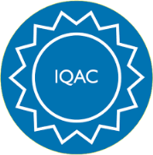

GOVERNMENT ARTS AND SCIENCE COLLEGE,
PERUMBAKKAM, CHENNAI-131

INTERNAL QUALITY ASSURANCE CELL
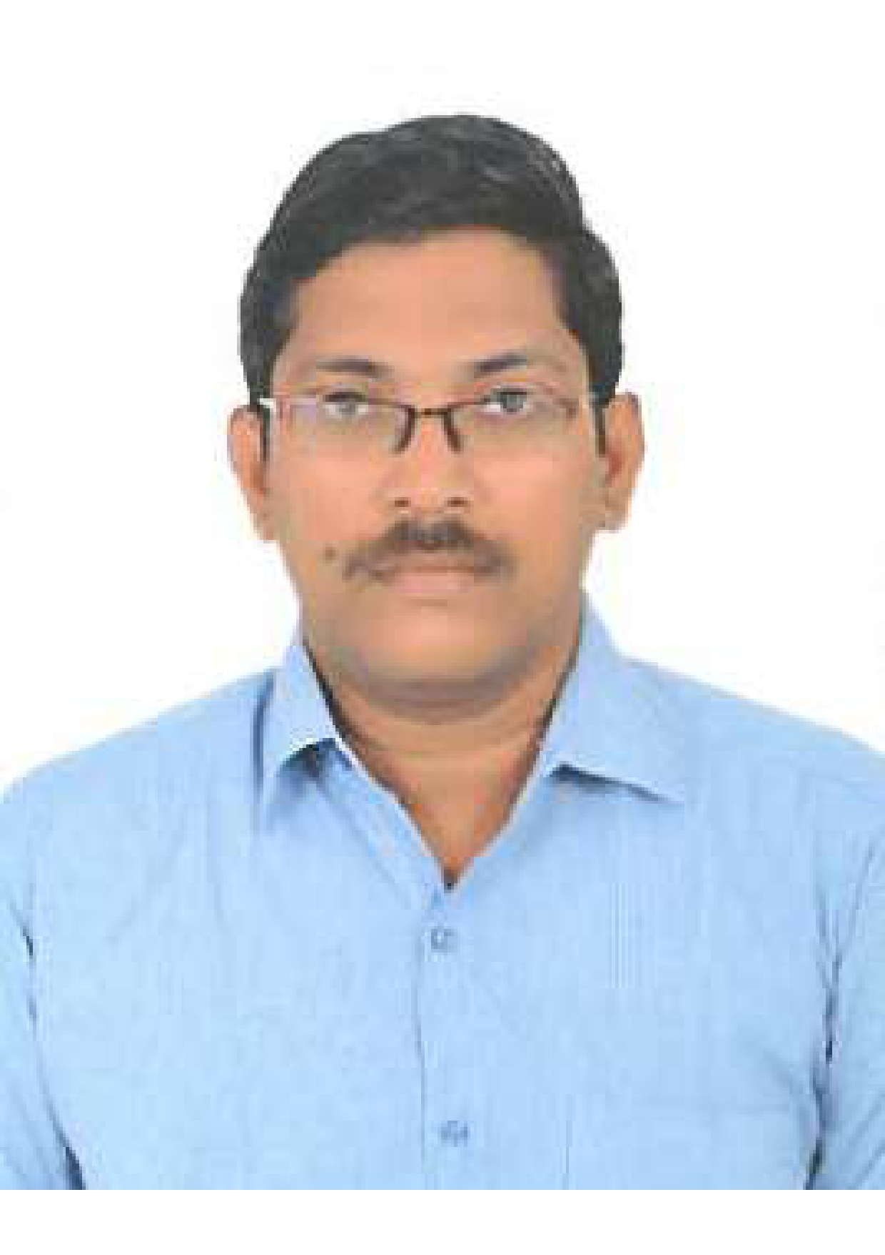

STAFF PROFILE REPORT

- GENERAL INFORMATION

a) Name and Designation : Dr.S.SARAVANAN

b) Department : English

c) Date of Joining : 09-07-2009
(Govt. Service)

d) Age and Date of Birth : 49 Years, 03-06-1977

e) Aadhar No. : 6178 9527 1817

f) PAN No. : COKPS0479D

g) Address for communication : 7/219,
MOGAPPAIR WEST, CHENNAI-600 037.

h) Permanent address : 7/219,
MOGAPPAIR WEST, CHENNAI-600 037.

i)Contact Number : 9176467798

j) Email id : saravananvishaal@yahoo.com

- ACADEMIC BACKGROUND

i) Academic Qualifications

Exam passed | Subjects/  Programme | College/  School Name | Board / University | Month & Year of Passing | Percentage | Division/ Grade/
Post-Doctoral | ---- | ----- | ----- | ----- | ----- | -----
Ph.D | English | L.N.Govt.College | University of Madras | 2022 | ---- | -----
M.Phil | English | Pachaiyappa’s College | University of Madras | August 2000 | 57 | II
PG | English | Loyola College, Chennai | University of Madras | April 1999 | 56 | II
UG | English | R.K.M.Vivekananda College,  Chennai | University of Madras | April 1997 | 57 | II
Any other | --- | --- | ---- | --- | --- | ---
HSC | PHY, CHE, MATHS, BIO | Vallal S.I.Alagarsamy Chettiar Hr.Sec.School, Chennai | TN STATE BOARD | March 1994 | 57.8 | II
SSLC | ---- | Vallal S.I.Alagarsamy Chettiar Hr.Sec.School, Chennai | TN STATE BOARD | March 1992 | 71 | I

ii) Research Experience & Training

Research stage | Year of Registration | Title of work / Thesis | University where the work was Carried out | Year of Award
M.Phil or equivalent | --- | --- | --- | ---
Ph.D. | --- | --- | ---- | ---
Post - Doctoral | --- | --- | --- | ---

iii) Professional Excellency summary (after entry to Govt. College)

Courses Taught | Name of the University/  College/ | Duration | Date  (From …..To) | Experience  in Govt. Service | Experience  Other than Govt. Service | Total Experience
i)UG | S.S.Govt.Arts College, Tiruttani | 1 Year | 09-07-2009 –  16-07-2010 | 17 Years | 9 Years | 26 Years
i)UG | L.N.Govt.College, Ponneri | 15Years | 19-07-2010 – 31-01-2026 | 17 Years | 9 Years | 26 Years
i)UG | Government Arts and Science College, Perumbakkam | 5 Months | 02-02-2026 – Till Date | 17 Years | 9 Years | 26 Years
ii)PG | L.N.Govt.College, Ponneri | 14 Years | 2012—  2026 | 14 Years | -- | 14 Years
iii)M.Phil | --- | --- | --- | --- | --- | ---
iv)Any other | --- | --- | --- | --- | ---- | ---

C) ACTIVITIES OF THE FACULTY MEMBERS

- Awards/Recognition received by the faculty
S. No | Year | Category | Date | Name of the award | Nature of the award medal/certificate/cash prize | Name of the Awarding Agency with Address & Contact Details | Level
--- | --- | --- | --- | --- | --- | --- | ---

- Member in Academic council/BOS/Professional Organisation

S. No | Year | Nature of Role | Duration | Date  ( From…. To) | Name of the Univ/College/ Organisation | Level
1

- Participation as resource person/inspection commission member/ Chief guest/ any other

S.No | Year | Nature of participation | Title of the Programme | Date | Name of the Institution /University/organization attended | Level
--- | --- | --- | --- | --- | --- | ---

- Member/Panel of examiners

S. No | Year | Name of the University /College | Position | Duration | Date  (From…. To)

- Membership in Professional Bodies

S.No | Year | Name of the  Professional body | Membership No | Nature of Membership | Duration | Date  (From…. To) | Level
--- | --- | --- | --- | --- | --- | --- | --

- Member of Editorial board (Journals/Books)
S.No | Year | Name of the Journal/Book | Position | Duration | Level
--- | --- | --- | --- | --- | ---

- Seminars/Workshop/Symposium/Hands on training (Organised)
S.No | Year | Programme Type | Position | Name of the Programme | Name of the Institute/University/  organization | Duration | Date  (From…. To) | Level
--- | --- | --- | --- | --- | --- | --- | --- | ---

- Participation in workshops/conference/symposium/seminar

S.No | Year | Category | Title of the sym/workshop/sem/  conf | Name of the College / University | Duration | Date  (From…. To) | Participation/  Presentation (Paper or Poster) | Title of the paper | Level
--- | --- | --- | --- | --- | --- | --- | --- | ---- | ---
- RESEARCH DETAILS : Research Supervisor
S.No | Year | Name of the University | Date of Recognition | Area of Specialisation | Remarks
--- | ---- | --- | --- | --- | ---

- Details of M.Phil/Ph.D Guided & Guiding
S.No | Month & Year of Registration | University under which guided/ guiding | Area of Specialisation | Nature of Registration | No of candidates &Name of the Scholar | Title of the dissertation | Status Completed/  ongoing
--- | --- | --- | --- | --- | --- | --- | ---

- List of PG Students Guided
S.No | Year | University under which guided | No of candidates guided | Area of Specialization | Status Completed/  ongoing
--- | --- | --- | --- | --- | ---

S.No | Batch | Register No | Name of the College | Name of the Student | Title of the dissertation | University under which guided | Status &  Date of completion
--- | --- | --- | --- | --- | --- | --- | ---
- Research projects undertaken
S.No | Year& Date of Sanction | Type of Project | Duration of the project | Title of the project | Funding agency | Fund Sanctioned | Status  Completed/ongoing
--- | --- | --- | --- | --- | --- | --- | ---

- Patent details
S.No | Year | Patent Title | Type | Patent No.
--- | ---- | --- | ---- | ---

- Publication of research articles/ abstracts in seminar/ conference proceedings
S.No | Year | Title of the sem/ conf | Level of Publication  National/ International | Name of the Journal | Title of the article/  Abstract | Details of publisher | Month & Year of Publication | ISSN/ISBN  No. | Citation index/  impact  factor
--- | --- | --- | --- | --- | --- | --- | ---- | --- | ---

- Publication in Journals
S.No | Year | Name of the Journal | Level of Publication  National/ International | UGC Listed Journal | Title of the Paper | Month & Year of Publication | ISSN/ISBN  No. | Citation index/  impact factor | Print/online
--- | --- | --- | --- | --- | --- | --- | --- | --- | ---

- Publication in Books
S.No | Year | Name of the book | Title of the Chapter | Author/Co-Author/  Translator | Details of publisher | ISBN  No. | Contribution | Status  Print/  Online | Level
--- | --- | --- | --- | --- | --- | --- | --- | --- | ---

xvii) Articles Published (Magazines)
S.No | Year | Category | Title | Name of the Magazine | Author/  Co-Author | Details of publisher | ISBN  No. | Level
--- | ---- | ---- | ---- | --- | ---- | --- | --- | ---

xviii) Member of Various Committees/Extension activities in the college/other institutions
S.No | Year | Name of the Committee | Position/  Level | Nature of the activity | Place where the activity was undertaken | Individual/  collaborative activity | Duration | Significance of the activity
--- | --- | --- | --- | --- | --- | --- | --- | ---

xix) Social Activities/Outreach Programmes

S.No | Year | Type of activity | Name of the Organisation | Duration
--- | --- | --- | --- | ---

- Participation in Orientation/Refresher/ FDP/STP
S.No | Year | Category | Title | Name of the University/Organisation | Duration | Date  (From…. To) | Sponsor
1 | 2009 | Orientation | --- | ASC, University of Madras | 28 Days | 09-07-2009 to 05-08-2009 | ---
2 | 2012 | Refresher | English | ASC, University of Madras | 21 Days | 28-08-2012 to 17-09-2012 | ---
3 | 2018 | Refresher | English | HRDC, University of North Bengal, Darjeeling | 21 Days | 09-01-2018 to 29-01-2018 | ---
4 | 2019 | Refresher | English | HRDC, Ranchi University, Ranchi | 14 Days | 12-06-2018 to 25-06-2019 | ---
5 | 2022 | Refresher | English | HRDC, University of Madras | 14 Days | 14-06-2022 to 27-06-2022 | ---

Dear Professors kindly attach the scanned documents along with your profile.
- Appointment order
- NET/SLET/Ph.D
- Transfer / Deputation order
- Aadhar
- PAN
- Degree Certificate
- Supporting documents for Awards/ Invited speaker/ seminar/workshop/BOS/Membership in professional bodies/ Ph.D guideship / Projects/ Publications/ Editorial board member / Orientation/ Refresher/ FDP/STP/social responsibility
- Any other achievements(if any) list out
(like getting additional degrees (in the past seven years, visit to foreign countries- name of the country, purpose of the visit, etc.,)

