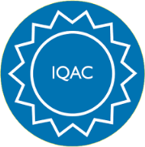

GOVERNMENT ARTS AND SCIENCE COLLEGE,
PERUMBAKKAM, CHENNAI-131

INTERNAL QUALITY ASSURANCE CELL
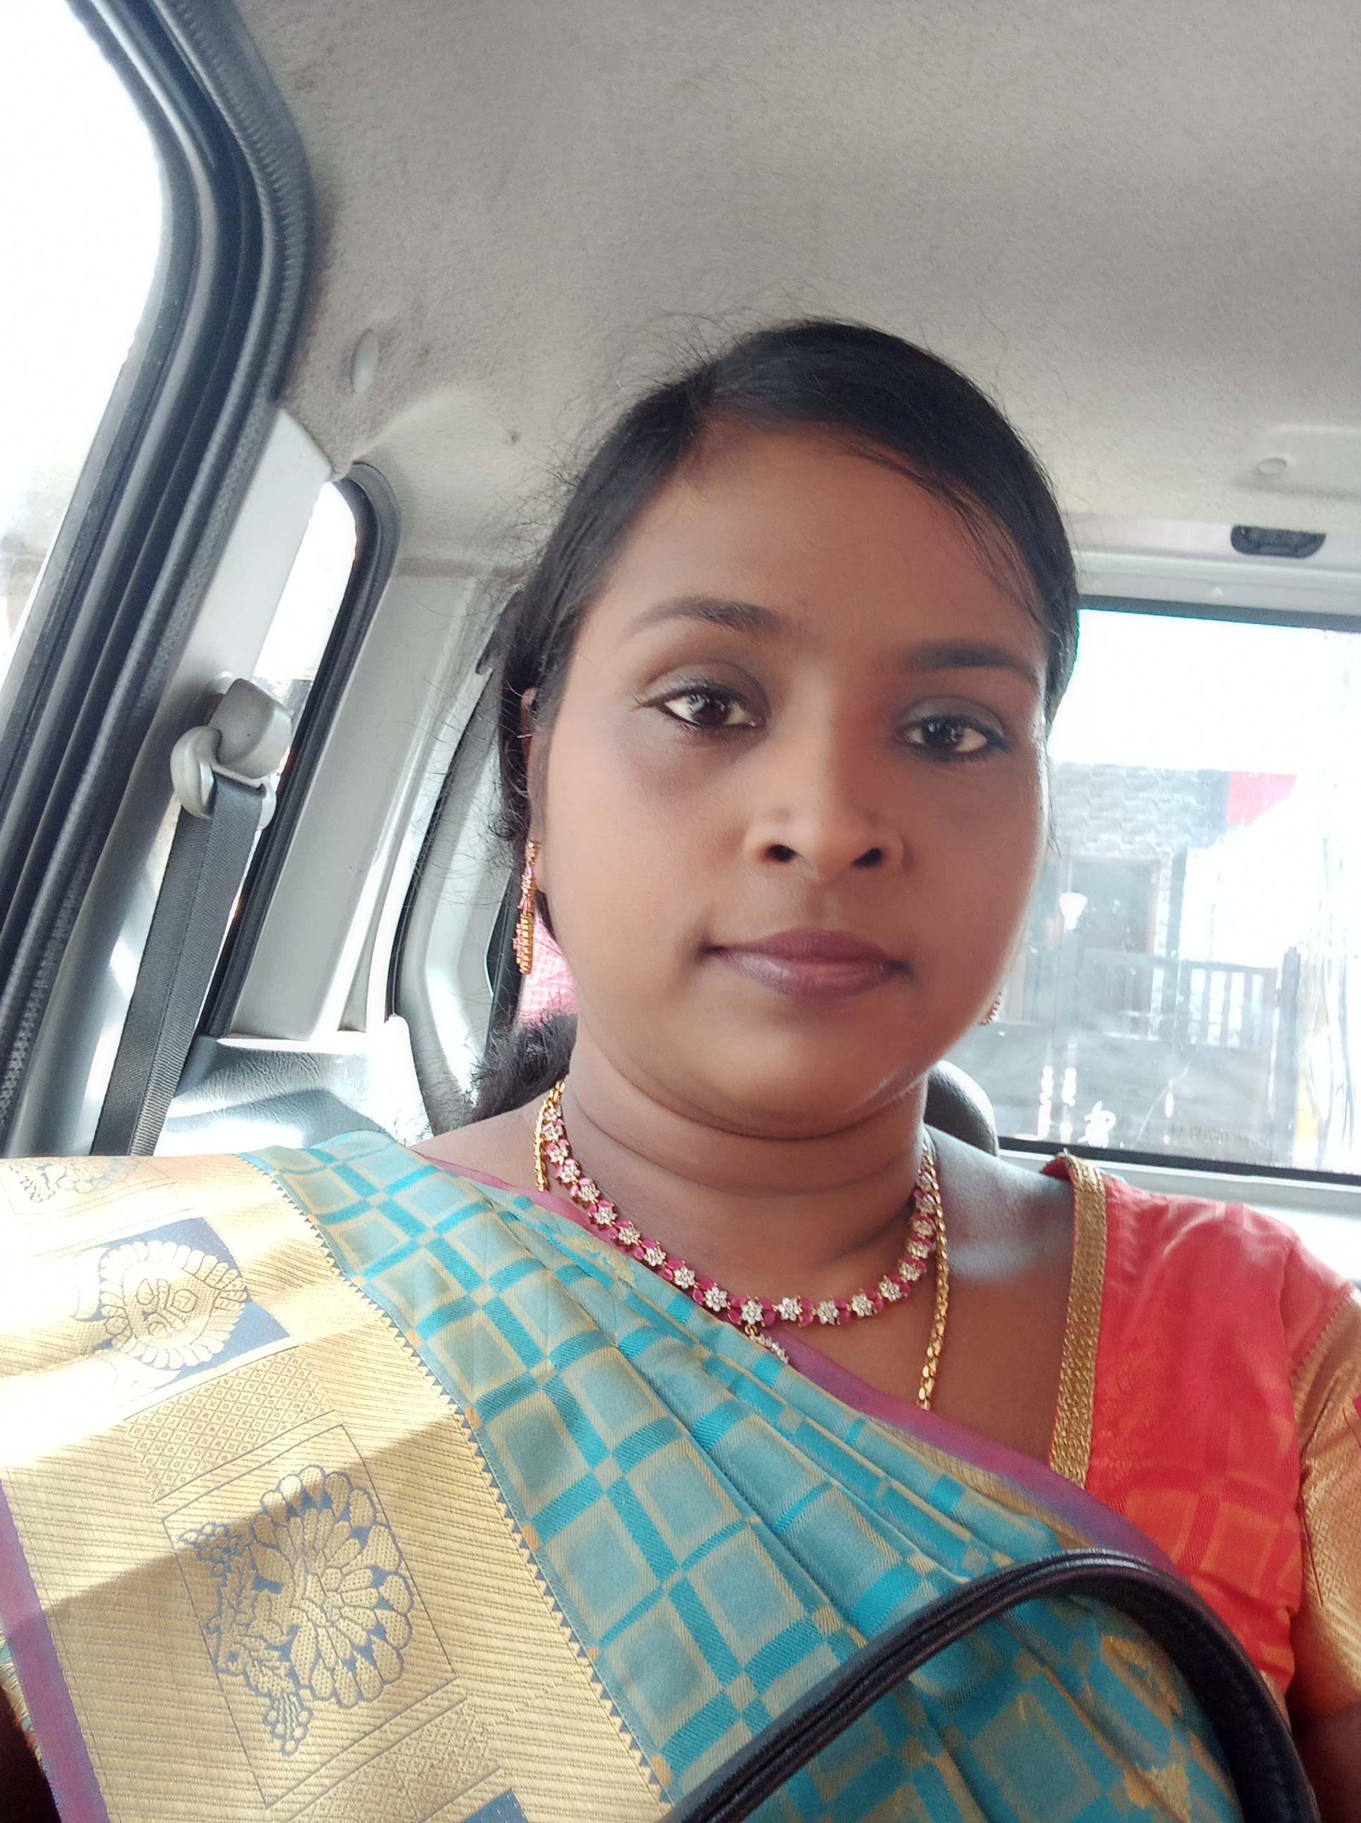

STAFF PROFILE REPORT

- GENERAL INFORMATION

a) Name and Designation : Dr. Hebsibah Paulin

b) Department : Computer Science

c) Date of Joining : 28-02-2011
(Govt. Service)

d) Age and Date of Birth : 47 (30-09-1977)

e) Aadhar No. : 617940217332

f) PAN No. : APYPP0755L

g) Address for communication : NO.173/33, New Balaji
Nagar Ext, Selaiyur Chennai - 600073

h) Permanent address : NO.173/33, New Balaji
Nagar Ext, Selaiyur Chennai - 600073
i)Contact Number : 8903705017

j) Email id : hepsibah.paulin@gmail.com

- ACADEMIC BACKGROUND

- Academic Qualifications

Exam passed | Subjects/  Programme | College/  School Name | Board / University | Month & Year of Passing | Percentage | Division/ Grade/
Post-Doctoral
Ph.D | Computer Science | Bharathiyaar University | Bharathiyaar University | June 2022 | Highly Commendable | Ist
M.Phil | Computer Science | Bharathidasan University | Bharathidasan University | Dec 2004 | 78% | Ist
PG | MCA | Madras Christian College | Madras University | April 2001 | 75% | Ist
UG -- | B.Sc Physics | Womens Christian College | Madras University | April 1998 | 75% | Ist
Any other
HSC | Bio-Maths | Kendriya Vidyalaya , AFS, Tambaram | CBSE | April 1995 | 76%
SSLC | CBSE | Kendriya Vidyalaya , AFS, Tambaram | CBSE | April 1993 | 77%

ii) Research Experience & Training

Research stage | Year of Registration | Title of work / Thesis | University where the work was Carried out | Year of Award
M.Phil or equivalent | 2002 | Analysis of Squeaky Wheel Algorithm | Bharathidasan | 2004
Ph.D. | 2014 | Audio Visual Speech Recognition System using Deep Neural Network | Bharathiyaar | 2022
Post - Doctoral

iii) Professional Excellency summary (after entry to Govt. College)

Courses Taught | Name of the University/  College/ | Duration | Date  (From …..To) | Experience  in Govt. Service | Experience  Other than Govt. Service | Total Experience
i)UG | Thiruvalluvar University  Madras University | 1 year  17.5 yrs | 11-02-2011 to 12-08-2012  07-03-200 to 16-10-2006  28-02-2011 till date | 1  12 yrs | 4.5 | 17.5
ii)PG | Madras University | 5 yrs | 2014 to 2018  2002 to 200 | 4 yrs | 1yrs | 5 yrs
iii)M.Phil
iv)Any other

C) ACTIVITIES OF THE FACULTY MEMBERS

- Awards/Recognition received by the faculty
S. No | Year | Category | Date | Name of the award | Nature of the award medal/certificate/cash prize | Name of the Awarding Agency with Address & Contact Details | Level

- Member in Academic council/BOS/Professional Organisation

S. No | Year | Nature of Role | Duration | Date  ( From…. To) | Name of the Univ/College/ Organisation | Level

- Participation as resource person/inspection commission member/ Chief guest/ any other

S.No | Year | Nature of participation | Title of the Programme | Date | Name of the Institution /University/organization attended | Level
1 | 2008 | Resource Person |  | 2008 | Madras Christian College
 | 2019 | Resource Person | Seminar | 2019 | R.V Govt Arts and Science College Chengalpattu

- Member/Panel of examiners

S. No | Year | Name of the University /College | Position | Duration | Date  (From…. To)
1 | 2023 | Quade Milleth College for Woman | Question Paper Setter and External Evaluator | 1 | 2023 till date

- Membership in Professional Bodies

S.No | Year | Name of the  Professional body | Membership No | Nature of Membership | Duration | Date  (From…. To) | Level
1 | 2022 | ICT | College Member | College Co-ordinator | 2 | 2022 till date

- Member of Editorial board (Journals/Books)
S.No | Year | Name of the Journal/Book | Position | Duration | Level

- Seminars/Workshop/Symposium/Hands on training (Organised)
S.No | Year | Programme Type | Position | Name of the Programme | Name of the Institute/University/  organization | Duration | Date  (From…. To) | Level
1 | 2023 | Placement Training | Coordinator | Capacity Building and Personality Development | Government Arts and Science College Perumbakkam | 15 days | 20-02-2023 to 10-03-2023

- Participation in workshops/conference/symposium/seminar

S.No | Year | Category | Title of the sym/workshop/sem/  conf | Name of the College / University | Duration | Date  (From…. To) | Participation/  Presentation (Paper or Poster) | Title of the paper | Level
- RESEARCH DETAILS : Research Supervisor
S.No | Year | Name of the University | Date of Recognition | Area of Specialisation | Remarks

- Details of M.Phil/Ph.D Guided & Guiding
S.No | Month & Year of Registration | - University under which guided/ guiding | Area of Specialisation | Nature of Registration | No of candidates &Name of the Scholar | Title of the dissertation | Status Completed/  ongoing

- List of PG Students Guided
S.No | Year | University under which guided | No of candidates guided | Area of Specialization | Status Completed/  ongoing

S.No | Batch | Register No | Name of the College | Name of the Student | Title of the dissertation | University under which guided | Status &  Date of completion
- Research projects undertaken
S.No | Year& Date of Sanction | Type of Project | Duration of the project | Title of the project | Funding agency | Fund Sanctioned | Status  Completed/ongoing

- Patent details
S.No | Year | Patent Title | Type | Patent No.

- Publication of research articles/ abstracts in seminar/ conference proceedings
S.No | Year | Title of the sem/ conf | Level of Publication  National/ International | Name of the Journal | Title of the article/  Abstract | Details of publisher | Month & Year of Publication | ISSN/ISBN  No. | Citation index/  impact  factor
 | 2018–19 | International Conference on Computing Science(Chennai, India: Layola College, 2018–19 | International |  | A Study on Various Speech Recognition System Techniques with Special Reference to Speech Recognition System Using Deep Neural Network |  | 2018–19
 | 2018 |  |  | International Journal of Pure and Applied Mathematics119 | Efficient Pre Processing of Audio and Video Signal Dataset for Building an Efficient Automatic Speech Recognition System |  |  | ISSN 1314-3395 | 7.19
 | 2019 |  |  | Journal of Testing and Evaluation | Audio–Visual (Multimodal) SpeechRecognitionSystemUsing Deep Neural Network |  |  | DOI: 10.1520/JTE20180505

- Publication in Journals
S.No | Year | Name of the Journal | Level of Publication  National/ International | UGC Listed Journal | Title of the Paper | Month & Year of Publication | ISSN/ISBN  No. | Citation index/  impact factor | Print/online

- Publication in Books
S.No | Year | Name of the book | Title of the Chapter | Author/Co-Author/  Translator | Details of publisher | ISBN  No. | Contribution | Status  Print/  Online | Level

xvii) Articles Published (Magazines)
S.No | Year | Category | Title | Name of the Magazine | Author/  Co-Author | Details of publisher | ISBN  No. | Level

xviii) Member of Various Committees/Extension activities in the college/other institutions
S.No | Year | Name of the Committee | Position/  Level | Nature of the activity | Place where the activity was undertaken | Individual/  collaborative activity | Duration | Significance of the activity
1 | 2020 till date | Placement | Coordinator | Trainingand Organizing Job Fair | Government Arts and Science College Perumbakkam | collaborative activity | 4 | Provided job offers to the passed out students of our college
2 | 2021-2023 | IQAC | Coordinator | Internal Quality Assurance Team | Government Arts and Science College Perumbakkam | collaborative activity | 2 | Document Maintenance and updation
3 | 2022-2024 | Website Co-ordinator | Madras University | Designing College Website | Government Arts and Science College Perumbakkam | Individual | 2 | Created college website
4 | 2022- till date | E-Governance | Nodal Officer | E-governance portal updation | Government Arts and Science College Perumbakkam | Individual | 2 | Data collection and updating the e-governance portal website
5 | 2022 till date | Naan Mudalvan | SPOC | SPOC for implementing NM Courses in our college | Government Arts and Science College Perumbakkam | Individual | 2 | Coordinating with TNSDC to implement NM Courses and ensuring all the students complete the course and receive the certificates.
6 | 2023 till date | Women Redressal Cell | Coordinator |  | Government Arts and Science College Perumbakkam | collaborative activity | 1 | Addressing the issues faced by women students
7 | 2023 till date | OSA | Executive Member |  | Government Arts and Science College Perumbakkam |  |  | Alumini Meet

xix) Social Activities/Outreach Programmes

S.No | Year | Type of activity | Name of the Organisation | Duration

- Participation in Orientation/Refresher/ FDP/STP
S.No | Year | Category | Title | Name of the University/Organisation | Duration | Date  (From…. To) | Sponsor
1 | 2011 | UGC | Orientation | Madras University | 28 | 05-05-2011 to  02-06-2011 | UGC
2 | 2013 | UGC | Orientation | Madras University | 28 | 04-09-2013  01-10-2013 | UGC
3 |  | UGC | refresher course | Bharathidasan University | 21 | 26-11-2015  03-12-2015 | UGC
4 | 2018 | UGC | refresher course | Madras University | 21 | 01-02-2018  21-02-2018 | UGC
5 | 2021 | UGC | refresher course | Madras University | 14 | 28-01-2021  10-02-2021 | UGC
6 | 2022 | UGC | refresher course | Madras University | 14 | 15-11-2022  28-11-2022 | UGC

Dear Professors kindly attach the scanned documents along with your profile.
- Appointment order
- NET/SLET/Ph.D
- Transfer / Deputation order
- Aadhar
- PAN
- Degree Certificate
- Supporting documents for Awards/ Invited speaker/ seminar/workshop/BOS/Membership in professional bodies/ Ph.D guideship / Projects/ Publications/ Editorial board member / Orientation/ Refresher/ FDP/STP/social responsibility
- Any other achievements(if any) list out
(like getting additional degrees (in the past seven years, visit to foreign countries- name of the country, purpose of the visit, etc.,)

