

GOVERNMENT ARTS AND SCIENCE COLLEGE,
PERUMBAKKAM, CHENNAI-131

INTERNAL QUALITY ASSURANCE CELL

STAFF PROFILE REPORT

- GENERAL INFORMATION

a) | Name and Designation | : | Dr. Samdanielthompson G. & Guest Lecture
b) | Department | : | Mathematics
c) | Date of Joining  (Govt. Service) | : | 10-02-2023
d) | Age and Date of Birth | : | 32 & 13-03-1990
e) | Aadhar No | : | 223483474680
f) | PAN No. | : | EPGPS3585M
g) | Address for Communication | : | No. 68, 3rd Cross Street, Bagavathy Nagar, Nandhivaram-Guduvanchery, Chengalpattu District – 603202
h) | Permanent Address | : | No. 111, Sadras Road, Thirukkalukundram, Chengalpattu District – 603109
i) | Contact Number | : | +91 – 9952923233
j) | Email Id | : | samdanielthompson@gmail.com
- ACADEMIC BACKGROUND
i) Academic Qualifications
Exam passed | Subjects/  Programme | College/  School Name | Board / University | Month & Year of Passing | Percentage | Division/ Grade/
Post-Doctoral | Nil
Ph.D | Mathematics | Madras Christian College | University of Madras | Jan, 2018 | NA | NA
M.Phil | Mathematics | Madras Christian College | University of Madras | Aug, 2014 | 91.5 | First Class with Exemplary
PG | Mathematics | Madras Christian College | University of Madras | April, 2013 | 88.65 | First Class with Distinction
UG | Mathematics | Madras Christian College | University of Madras | April, 2011 | 81 | First Class
Any other | Diploma in Computer Science | CTC Info media Computer Education | NA | 2009 | 80 | First Class
HSC | Bio-Maths | V.S Matric. Hr. Sec. School | TN - Higher secondary | May, 2008 | 75.67 | First Class
SSLC | Matriculation | V.S Matric. Hr. Sec. School | TN - Matriculation | May, 2006 | 77.45 | First Class
ii) Research Experience & Training
Research stage | Year of Registration | Title of work / Thesis | University where the work was Carried out | Year of Award
M.Phil or equivalent | 2013 | Domination in Fuzzy Graphs | University of Madras  (Madras Christian College) | 2014
Ph.D. | 2015 | String and Array Grammar System Based on Flat Splicing Operation | University of Madras  (Madras Christian College) | 2018
Post - Doctoral | Nil
iii) Professional Excellency summary (after entry to Govt. College)
Courses Taught | Name of the University/  College/ | Duration | Date  (From …..To) | Experience  in Govt. Service | Experience  Other than Govt. Service | Total Experience
i)UG | Govt. Arts & Science College, Perumbakam |  | 10.02.2023 to till Date |  |  | 4 Years & 8 Months
i)UG | Hindustan College of Arts & Science, Chennai | 4 years & * Months | 04.06.2018 to 09.02.2023 |  | 4 yeas & 8 Months | 4 Years & 8 Months
ii)PG | Nil
iii)M.Phil | Nil
iv)Any other | Nil
- ACTIVITIES OF THE FACULTY MEMBERS
- Awards/Recognition received by the faculty
S. No | Year | Category | Date | Name of the award | Nature of the award medal/certificate/cash prize | Name of the Awarding Agency with Address & Contact Details | Level
Nil
- Member in Academic council/BOS/Professional Organisation
S. No | Year | Nature of Role | Duration | Date  (From…. To) | Name of the Univ/College/ Organisation | Level
Nil
- Participation as resource person/inspection commission member/ Chief guest/ any other
S.No | Year | Nature of participation | Title of the Programme | Date | Name of the Institution /University/organization attended | Level
Nil
- Member/Panel of examiners
S. No | Year | Name of the University /College | Position | Duration | Date  (From…. To)
Nil
- Membership in Professional Bodies
S.No | Year | Name of the  Professional body | Membership No | Nature of Membership | Duration | Date  (From…. To) | Level
- Member of Editorial board (Journals/Books)
S.No | Year | Name of the Journal/Book | Position | Duration | Level
Nil
- Seminars/Workshop/Symposium/Hands on training (Organised)
S.No | Year | Programme Type | Position | Name of the Programme | Name of the Institute/University/  organization | Duration | Date  (From…. To) | Level
Nil
- Participation in workshops/conference/symposium/seminar

S.No | Year | Category | Title of the sym/workshop/sem/  conf | Name of the College / University | Duration | Date  (From…. To) | Participation/  Presentation (Paper or Poster) | Title of the paper | Level
1 | 2022 | Virtual Conference | Curriculum Designing and Transaction Under the Proposal UGC Curriculum Framework | Nirmala College, | 2 Days | 28.07.2022 to 29.07.2022 | Participation
2 | 2022 | Workshop | Question Paper Typing in Latex | VIT, Chennai, | 1 Day | 30.06.2022 | Participation

3 | 2022 | Workshop | Introduction to Mathematical Ecology | SRMIST | 1 Day | 5.02.2023 | Participation
4 | 2022 | International Conference | Advancements in Applicable Mathematics | SIVET College., Chennai | 1 Day | 07.03.2022 | Participation
5 | 2022 | Webinar | Innovative Variations of Animagic Labellings | SIMATS, Chennai | 1 Day | 07.09.2022 | Participation
6 | 2022 | Webinar | Experiential learning as Envisaged in NEP 2020 | SGTB Khalsa College, Delhi | 1 Day | 19.06.2022 | Participation
- Research Details: Research Supervisor
S.No | Year | Name of the University | Date of Recognition | Area of Specialisation | Remarks
- Details of M.Phil. / Ph.D. Guided & Guiding
S.No | Month & Year of Registration | University under which guided/ guiding | Area of Specialisation | Nature of Registration | No of candidates &Name of the Scholar | Title of the dissertation | Status Completed/  ongoing
Nil
- List of PG Students Guided
S.No | Batch | Register No | Name of the College | Name of the Student | Title of the dissertation | University under which guided | Status &  Date of completion
Nil
- Research projects undertaken
S.No | Year& Date of Sanction | Type of Project | Duration of the project | Title of the project | Funding agency | Fund Sanctioned | Status  Completed/ongoing
Nil
- Patent details
S.No | Year | Patent Title | Type | Patent No.
Nil
- Publication of research articles/ abstracts in seminar/ conference proceedings
S.No | Year | Title of the sem/ conf | Level of Publication  National/ International | Name of the Journal | Title of the article/  Abstract | Details of publisher | Month & Year of Publication | ISSN/ISBN  No. | Citation index/  impact  factor
1 | 2021 | International Conference on Artificial Intelligence and Information Technology | International | Conference Proceedings | Double Divisor Cordial labelling of Star Related Graphs |  | 2021 | ISBN: 978-81-89843-12-0)
2 | 2020 | Soft Computing for Problem Solving 2019. Advances in Intelligent Systems and Computing | International | Soft Computing for Problem Solving 2019. Advances in Intelligent Systems and Computing, | Flat Splicing-Based Generative Model for Hexagonal Picture Array Languages | Springer | April 2020 | 978-981-15-3290-0
3 | 2018 | CDMTCS-530 | International | CDMTCS Research Report Series | Insertion Based Picture Array P Systems, | University of Auckland, New Zealand, | 2018
4 | 2017 | Theoretical Computer Science and Discrete Mathematics | International | LNCS- (Theoretical Computer Science and Discrete Mathematics) | Grammar Systems Based on Equal Matrix Rules and Alphabetic Flat Splicing, | Springer | 2017 | - 978-3-319-64418-9
5 | 2015 | Innovations in Bio-Inspired Computing and Applications | International | Advances in Intelligent Systems and Computing 424 | Generating Picture Arrays Based on Grammar Systems with Flat Splicing Operation | Springer | 2015 | - 978-3-319-28031-8

- Publication in Journals
S.No | Year | Name of the Journal | Level of Publication  National/ International | UGC Listed Journal | Title of the Paper | Month & Year of Publication | ISSN/ISBN  No. | Citation index/  impact factor | Print/online
1 | 2017 | Journal of Mathematics and Informatics | National | Yes | Alphabetic Flat Splicing Pure Context-Free Array Grammar System, | 2017 | ISSN 2349-0640 (Online) |  | Online
2 | 2022 | International Journal of Advanced Multidisciplinary Research and Studies | International | No | 0-Edge Magic Labeling of Some Graphs | 2022 | 2583-049X |  | Online
3 | 2016 | International Journal of Computer Information Systems and Industrial Management Applications, | International | No | Flat Splicing Array Grammar Systems Generating Picture Arrays | 2016 | ISSN 2150-7988 | Scopus | Online
4 | 2019 | Journal of Emerging Technologies  and Innovative Research | International | Yes | On Equitable Power Domination Number of Some Graphs, | 2019 | ISSN: 2349-5162 | UGC | Online
5 | 2020 | Journal of Emerging Technologies and Innovative Research | International | Yes | On Divisor 3-Equitable Labeling of Certain Graph | 2020 | ISSN: 2349-5162 | UGC | Online
6 | 2020 | Divisor Labeling of Some Special Graphs | International | No | Divisor Labeling of Some Special Graphs | 2020 | ISSN: 1742-6596 | Scopus | Online
7. | 2019 | International Journal of Engineering and Advanced Technology | International | No | Some Results on Prime and Distinct Prime Distance Labelling of Graphs | 2019 | ISSN: 2249-8958 | Scopus | Online
8. | 2016 | International Journal of Artificial Intelligence and Soft Computing | International | Yes | Flat Splicing Context-Free Array Grammar System for Generating Picture Arrays | 2016 | 1755-4969 | UGC | Online
9. | 2020 | Applied. Science | International | Yes | A Bio-Inspired Model of Picture Array Generating P System with Restricted Insertion Rules, | 2020 | ISSN: 2076-3417 | Web of Science, Scopus, UGC, IF 2.838 | Online
10 | 2021 | Indian J Pure Appl Math | International | No | On Finite Prime Distance Graphs | 2021 | 0975-7465 | Web of Science -SCIE, Impact factor: 0.571, Scopus | Online
11 | 2022 | Advances and Applications in Mathematical Sciences | International | Yes | Power Domination on Shadow Graph of Certain Graphs. | 2022 | 0974-6803 | Web of Science – ESCI, UGC Care-Group -I) | Online
- Publication in Books
S.No | Year | Name of the book | Title of the Chapter | Author/Co-Author/  Translator | Details of publisher | ISBN  No. | Contribution | Status  Print/  Online | Level
1 | 2019 | Bio-Inspired Computing Models and Algorithms | Picture Generating Models Based on Splicing Operation | K. G. Subramanian, G. Samdanielthompson, N.G. David, | World Scientific | 9789813143173 | Author | Print | Published
xvii) Articles Published (Magazines)
S.No | Year | Category | Title | Name of the Magazine | Author/  Co-Author | Details of publisher | ISBN  No. | Level
Nil
xviii) Member of Various Committees/Extension activities in the college/other institutions
S.No | Year | Name of the Committee | Position/  Level | Nature of the activity | Place where the activity was undertaken | Individual/  collaborative activity | Duration | Significance of the activity
xix) Social Activities/Outreach Programmes
S.No | Year | Type of activity | Name of the Organisation | Duration
- Participation in Orientation/Refresher/ FDP/STP
S.No | Year | Category | Title | Name of the University/Organisation | Duration | Date  (From…. To) | Sponsor

Dear Professors kindly attach the scanned documents along with your profile.
- Appointment order

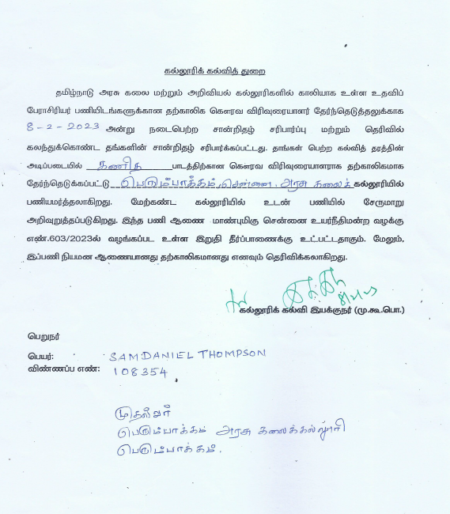
- NET/SLET/Ph.D

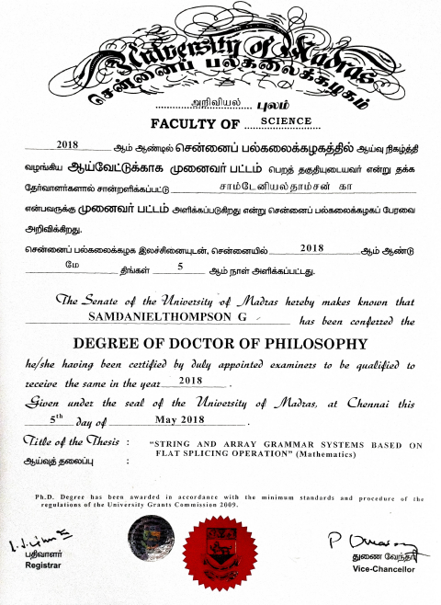

- Transfer / Deputation order NA
- Aadhar
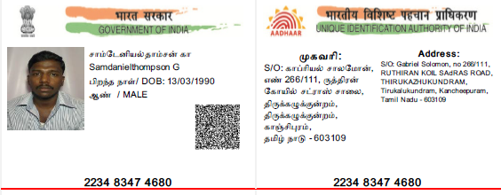
- PAN
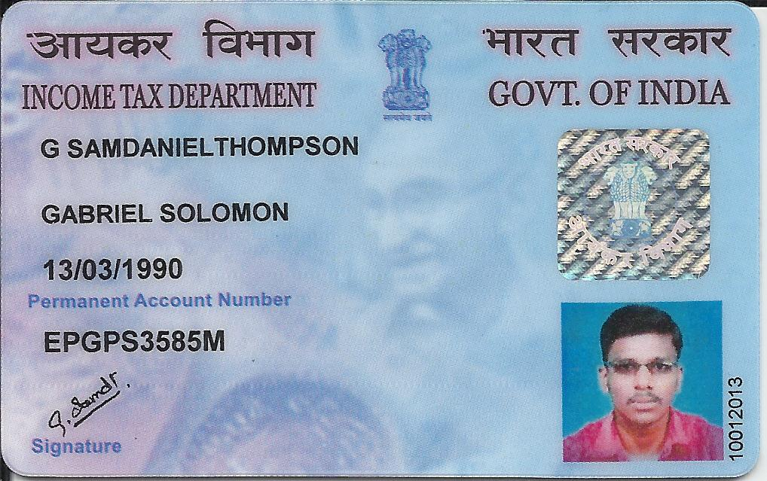
- Degree Certificate
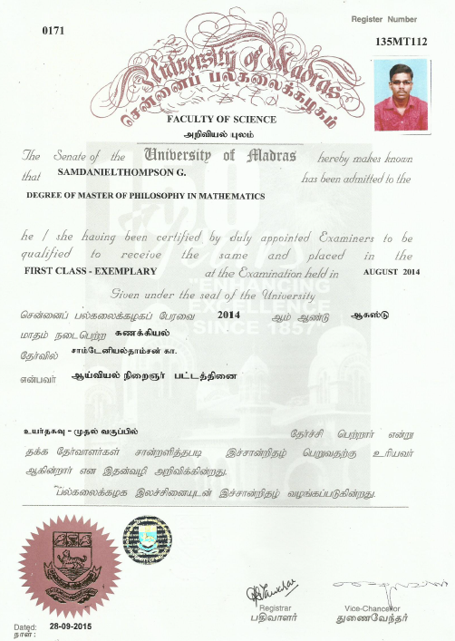

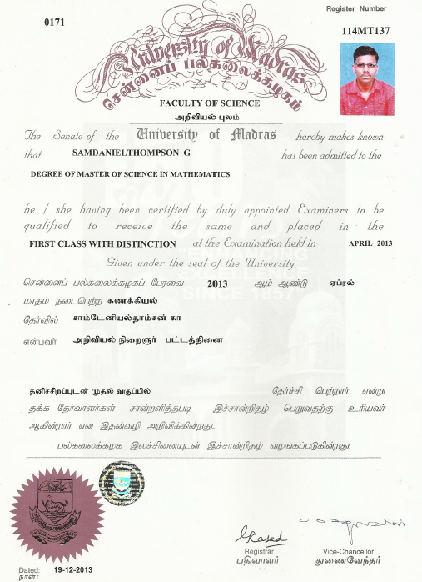

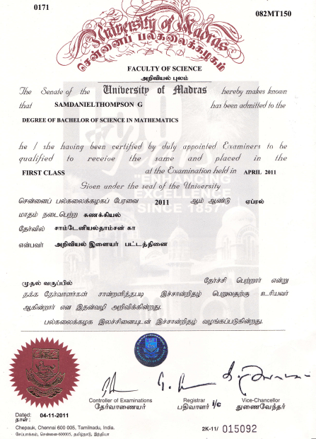
- Supporting documents for Awards/ Invited speaker/ seminar/workshop/BOS/Membership in professional bodies/ Ph.D guideship / Projects/ Publications/ Editorial board member / Orientation/ Refresher/ FDP/STP/social responsibility
- Any other achievements(if any) list out
(like getting additional degrees (in the past seven years, visit to foreign countries- name of the country, purpose of the visit, etc.,)

