

GOVERNMENT ARTS AND SCIENCE COLLEGE,
PERUMBAKKAM, CHENNAI-131

INTERNAL QUALITY ASSURANCE CELL
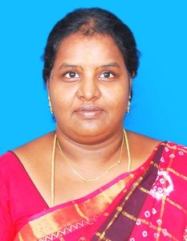

STAFF PROFILE REPORT

- GENERAL INFORMATION

a) Name and Designation : ASHWINI .I ,
ASSISTANT PROFESSOR

b) Department : MATHEMATICS

c) Date of Joining : 27/07/2015
(Govt. Service)

d) Age and Date of Birth : 34 YRS , 01.01.1988

e) Aadhar No. : 6580 4984 6374

f) PAN No. : BRSPA2330K

g) Address for communication : NO 20 NETHAJI STREET GANDHI NAGAR ,MADIPAKKAM P.O , CHENNAI -600 091

h) Permanent address : NO 20 NETHAJI STREET GANDHI NAGAR ,MADIPAKKAM P.O , CHENNAI -600 091

i)Contact Number : 8939613969

j) Email id : ashwini.bhuvan@gmail.com

- ACADEMIC BACKGROUND

i) Academic Qualifications

Exam passed | Subjects/  Programme | College/  School Name | Board / University | Month & Year of Passing | Percentage | Division/ Grade/
Ph.D | MATHEMATICS | ISLAMIAH COLLEGE ,VANIYAMBADI | THIRUVALLUVAR UNIVERSITY | SUBMITTED THESIS
M.Phil | MATHEMATICS | RIASM | MADRAS UNIVERSITY | AUG 2011 | 90% | FIRST CLASS WITH DISTINCTION
PG | MATHEMATICS | MEENAKSHI COLLEGE | MADRAS UNIVERSITY | JULY 2010 | 91% | FIRST CLASS WITH DISTINCTION
UG -- | MATHEMATICS | WCC, CHENNAI | MADRAS  UNIVERSITY | APRIL 2008 | 81 | FIRST CLASS
Any other | PGDCA | LIBA,LOYOLA | MADRAS UNIVERSITY |  |  | FIRST CLASS WITH DISTINCTION
HSC |  | ST.COLUMBANS  AIHSS | STATE BOARD | 2005 | 97% | FIRST CLASS WITH DISTINCTION
SSLC |  | ST.COLUMBANS  AIHSS | ANGLO INDIAN BOARD | 2003 | 84% | FIRST CLASS

ii) Research Experience & Training

Research stage | Year of Registration | Title of work / Thesis | University where the work was Carried out | Year of Award
M.Phil or equivalent | 2010 | ELLIPTIC CURVE CRYPTOGRAPHY | MADRAS UNIVERSITY | 2011
Ph.D. | SUBMITTED THESIS ON AUGUST 2025

iii) Professional Excellency summary (after entry to Govt. College)

Courses Taught | Name of the University/  College/ | Duration | Date  (From …..To) | Experience  in Govt. Service | Experience  Other than Govt. Service | Total Experience
i)UG | DGGAC , MAYILADUTHURAI  SSGAC, TIRUTTANI  GOVERNMENT ARTS AND SCIENCE COLLEGE  PERUMBAKKAM | 1 YEAR  5 YEARS  1 YEAR | 27.7.2015 – 28.7.2016  29.07.2016 –  02.3.2021  3.3.2021 -TIL DATE | 10 YEARS | 3 YEARS | 13 YEARS
ii)PG | DGGAC , MAYILADUTHURAI  SSGAC, TIRUTTANI  GOVERNMENT ARTS AND SCIENCE COLLEGE  PERUMBAKKAM | 1 YEAR  5 YEARS  2 YEARS | 27.7.2015 – 28.7.2016  29.07.2016 –  02.3.2021 | 8 YEARS | 3 YEARS | 11  YEARS

C) ACTIVITIES OF THE FACULTY MEMBERS

- Member in Academic council/BOS/Professional Organisation

S. No | Nature of Role | Duration | Date  ( From…. To) | Name of the Univ/College/ Organisation
1 | BOS ALUMINI MEMBER | 3 years | 2023-2026 | WCC, CHENAI  UNIVERSITY OF MADRAS

- Participation as resource person/inspection commission member/ Chief guest/ any other

S.No | Year | Nature of participation | Title of the Programme | Date | Name of the Institution /University/organization attended
1. | 2024 | INAUGURAL ADDRESS | INTERCOLLEGIATE FEST | 17.08.2024 | WCC CHENNAI
2. | 2024 | RESOURCE PERSON | ONE DAY WORKSHOP | 04.09.2024 | SRM ,CHENNAI
3. | 2025 | JUDGE | INTER SCHOOL COMPETITION – MATHLEAGUE | 01.11.2025 | SHIKSHAA PUBLIC SCHOOL CHENNAI

- Seminars/Workshop/Symposium/Hands on training (Organised)
S.No | Year | Programme Type | Position | Name of the Programme | Name of the Institute/University/  organization | Duration
1. | 2020 | ONLINE  QUIZ | CO-ORDINATOR | ONLINE MATH QUIZ | DEPARTMENT OF MATHEMATICS  SSGAC ,TIRUTTANI | 24.05.2020.
2. | 2020 | ONLINE QUIZ | CO-ORDINATOR | A QUIZ TO LEARN AND LIVE WITH  COVID-19 | IQAC,  SSGAC ,TIRUTTANI | 29.05.2020.
3. | 2021 | ONLINE MODE | CO-ORDINATOR | R PROGRAMMING | SPOKEN TUTORIAL,  IIT BOMBAY ,  FUNDED BY MHRD GOVERNMENT OF INDIA

IV ) PAPER PRESENTATIONS IN NATIONAL/ INTERNATIONAL CONFERENCE
S. No. | Name of the Staff | Title ofthe Paper | Title of the Proceedings ofthe Conference | Name ofthe Conference | National / International | Year of Presentation
1 | Mrs.I.Ashwini | Optimal Replacement Policy for Maintainance Model Under Partial Sum Process | International Conference on Global Trends and Subtleties in contemporary Mathematical Research | Igcmr23 | International Conference | 2023
2. | Mrs.I.Ashwini | A Bivariate Replacement Policy for an extreme Shock Maintenance Model under Partial Sum Process | International Conference on Mathematics and Applications | ICMA-2024 | International Conference | Feb 2024
3 | Mrs.I.Ashwini | A Bivariate Replacement Policy for an extreme Shock Maintenance Model under Partial Sum Process | International Conference on Recent Trends in Mathematical Science and Technology | RTMST-2024 | International Conference | March 2024

- Publication of research articles/ abstracts in seminar/ conference proceedings
S.No | Year | Title of the sem/ conf | Level of Publication  National/ International | Name of the Journal | Title of the article/  Abstract | Details of publisher | Month & Year of Publication | ISSN/ISBN  No. | Citation index/  impact  factor
11 | 2018 | CLIMATE AND ENVIRONMENTAL CHALLENGES : RETROSPECT AND PROSPECT | INTERNATIONAL |  | WORK PLACE ENVIRONMENT AND EMPLOYEE JOB SATISFACTION : AN EMPERICAL ASSESMENT |  | 6 FEB 2018

- Publication in Journals
S.No | Year | Name of the Journal | Level of Publication  National/ International | UGC Listed Journal | Title of the Paper | Month & Year of Publication | ISSN/ISBN  No. | Citation index/  impact factor | Print/online
1 | 2020 | IJCRT | INTERNATIONAL | 49023(18) | PADOVAN GRACEFUL LABELING | 8TH JULY 2020 | ISSN 2320 2882 | 7.97 | ONLINE

VII) Member of Various Committees/Extension activities in the college/other institutions
S.No | Year | Name of the Committee | Position/  Level | Place where the activity was undertaken | Duration
1. | 2017 | WOMEN’S CELL | CO-CORDINATOR | SSGAC,  TIRUTTANI | 2016-2018
2. | 2019 | IQAC, RUSA | MEMBER | SSGAC,  TIRUTTANI | 2017-2018
3. | 2022 | IQAC | MEMBER | GOVERNMENT ARTS AND SCIENCE COLLEGE PERUMBAKKAM | 2022-2026
4 | 2021 | EXAM CELL | MEMBER | GOVERNMENT ARTS AND SCIENCE COLLEGE PERUMBAKKAM | 2021-2022
5 | 2025 | FINE ARTS | MEMBER | GASCP | 2025-2027
6 | 2024 | COLLEGE CALENDAR | MEMBER | GASCP | 2024-2026

- Participation in Orientation/Refresher/ FDP/STP
S.No | Year | Category | Title | Name of the University/Organisation | Duration | Date  (From…. To) | Sponsor
1. | 2017 | ORIENTATION |  | MADRAS UNIVERSITY | 27 DAYS | 10.05.2017 TO 06.06.2017 | UGC
2. | 2020 | REFRESHER | MATHEMATICS &STATISTICS | MADRAS UNIVERSITY | 14 DAYS | 07.10.2020 TO 20.10.2020 | UGC
3. | 2022 | REFRESHER | MATHEMATICS &STATISTICS | MADRAS UNIVERSITY | 14 DAYS | 16.08.2022 TO 29.08.2022 | UGC
4. | 2021 | FDP | SWAYAM | NPTEL-AICTE  FDP -8 WEEKS | 8 WEEKS | AUG- OCT 2021
5. | 2021 | FDP | SWAYAM | NPTEL  FDP-8 WEEKS | 8 WEEKS | JAN-MARCH 2021
6. | 2022 | FDP | In-Service two days Teacher Training Program. | MADRAS UNIVERSITY | 2 DAYS | 19.04.2022 & 20.04.2022 | TANSCHE
7 | 2024 | FDP | NAN MUDHALVAN | DRONE PILOTS – NAN MUDHALVAN | JUNE 2024 | JUNE 2024 | 6 DAYS
7 | 2023 | FDP | NAN MUDHALVAN | FDP on”Fundamentals of Analytics with Tableau “ | 24 .07.2023 | 28.07.2023 | 5 days
8 | 2023 | REFRESHER |  | RAMANUJAN DELHI UNIVERSITY | 23.02.2023 | 09.03.2023 | 14 days

LIST OF PUBLICATIONS

[1] ASHWINI, I., ZAHIRUDDEEN AND RIZWAN, U., (2024), Optimal Replacement Model
for a Deteriorating System under Partial Sum Process, Journal of
Computational Analysis and Applications, 33 (4), 404 – 411.
[2] ASHWINI, I., SYED TAHIR HUSSAINY, ZAHIRUDDEEN AND RIZWAN, U., (2025), Optimal
Replacement Policy for a Multistate Degenerative System Using Partial Sum
Process in An Alternate Repair Model, Communications on Applied Nonlinear
Analysis, 32 (9S), 2359 – 2369.
[3] ASHWINI, I., SYED TAHIR HUSSAINY, ZAHIRUDDEEN AND RIZWAN, U., (2025), Optimal
Replacement Policy for a Multistate Degenerative System Using Partial Sum
Process with Varying Cost Structures, Advances in Nonlinear Variational
Inequalities, 28 (6S), 741 – 748.
[4] ASHWINI, I., ZAHIRUDDEEN AND RIZWAN, U., (2024), A Bivariate Replacement
Policy for an Extreme Shock Maintenance Model under Partial Sum Process,
Journal of Computational Mathematica, VIII (II), 031 – 051.
[5] ASHWINI, I., ZAHIRUDDEEN AND RIZWAN, U., (2024), A  -Shock Model for the
Replacement Policy T using Partial Sum Process With Nonn Repair Times,
Indian Journal of Natural Sciences, 15 (87), 85595 – 85599.
[6] ASHWINI, I., ZAHIRUDDEEN AND RIZWAN, U., (2025), Extreme Shock Maintenance
Model Under Some Bivariate Replacement Policy By Partial Sum Process
With Negligible Or Nonnegligible Repair Times, International Journal of
Creative Research Thoughts, 13 (3), H643 – H648.

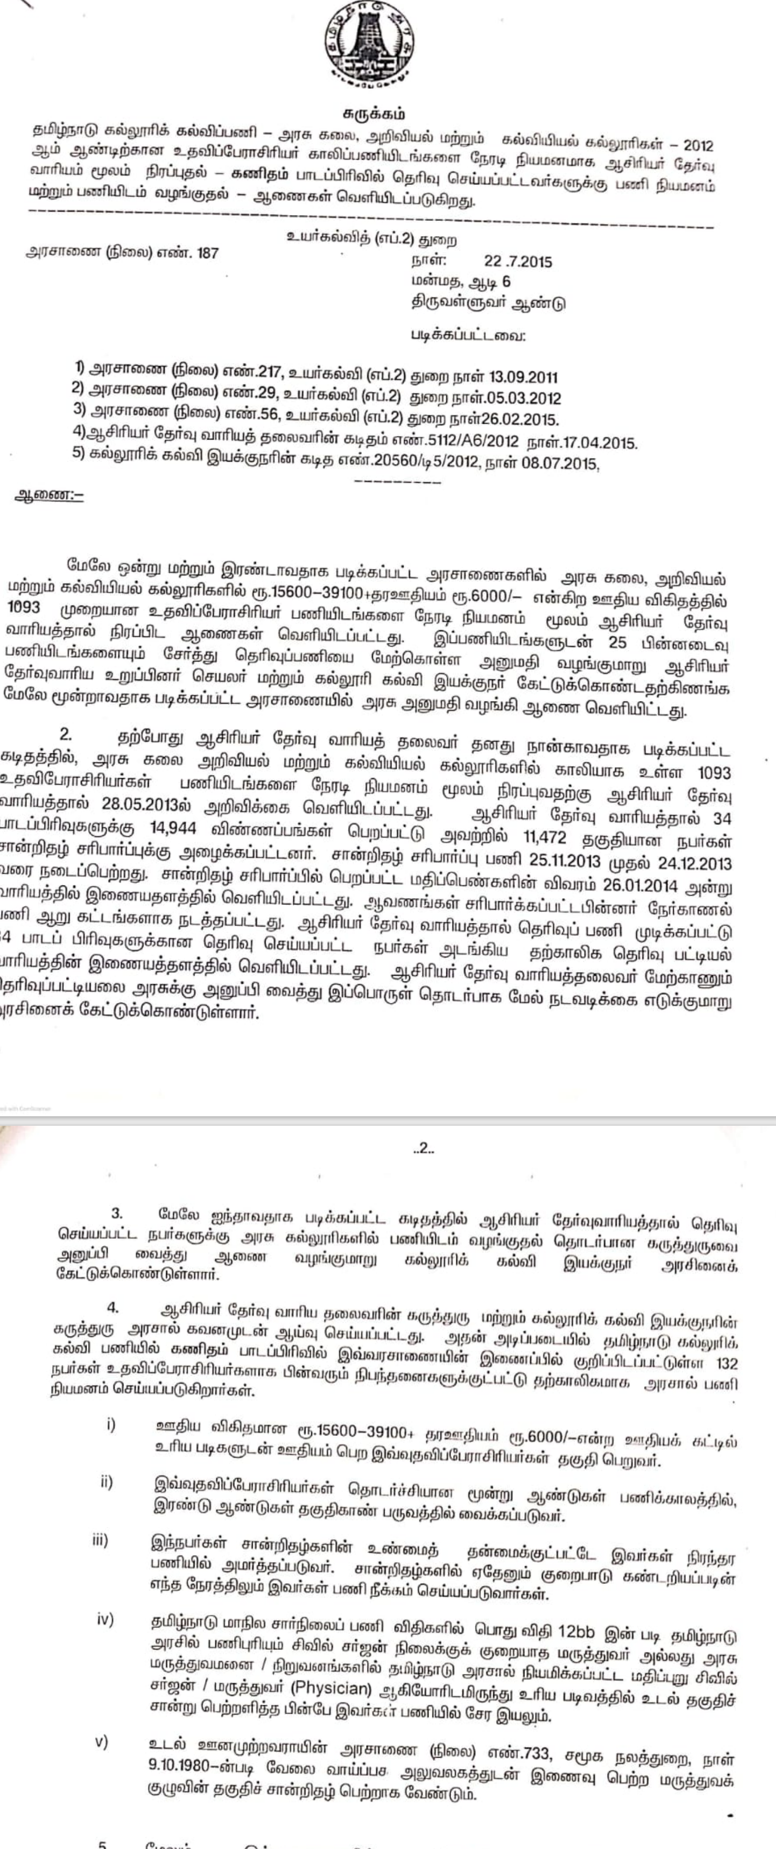
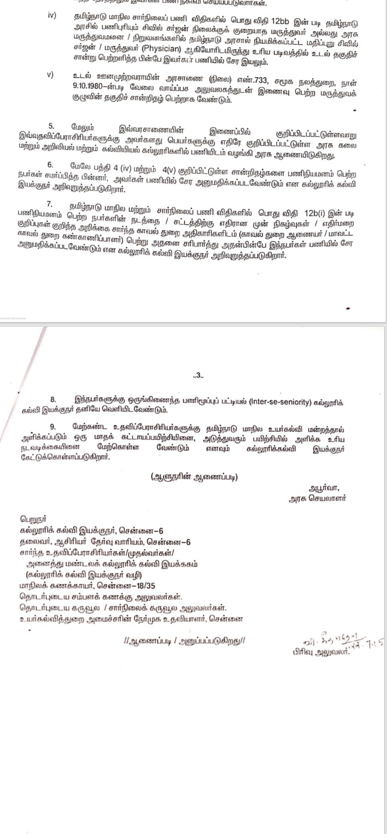
SET

