
GOVERNMENT ARTS AND SCIENCE COLLEGE,
PERUMBAKKAM, CHENNAI-131

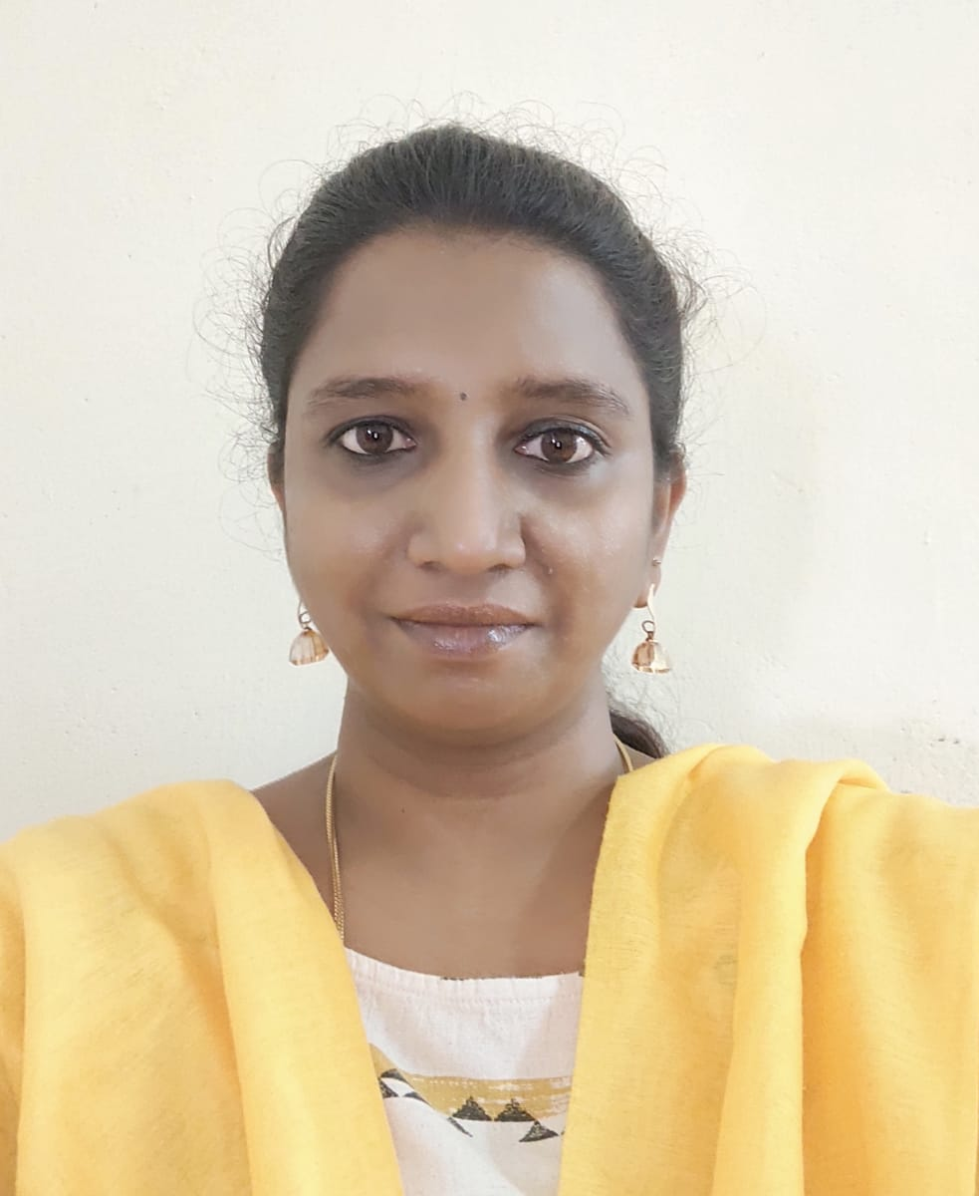

STAFF PROFILE REPORT

- GENERAL INFORMATION

a) Name and Designation : Lt. Arumugathai. C
Assistant Professor of English

b) Department : English

c) Date of Joining : 28 February 2011
(Govt. Service)

d) Age and Date of Birth : Age - 43 25 January 1983

e) Aadhar No. : 654621973527

f) PAN No. : AYBPA13198

g) Address for communication : 19 B, Nagarathinam Nagar
Thiruneermalai Road
West Tambaram
Chennai – 600 045

h) Permanent address : 19 B, Nagarathinam Nagar
Thiruneermalai Road
West Tambaram
Chennai – 600 045

i)Contact Number : 9677198290

j) Email id : arumugathai@gmail.com

- ACADEMIC BACKGROUND

i) Academic Qualifications

Exam passed | Subjects/  Programme | College/  School Name | Board / University | Month & Year of Passing | Percentage | Division/ Grade/
Post-Doctoral | - | - | - | - | - | -
Ph.D | English | Meenakshi College of Arts and Science  (Part Time) | Meenakshi Academy of Higher Education (Deemed to be University) | Pursuing | - | -
M.Phil | - | - | - | - | - | -
PG | M.A. English Language and Literature | Madras Christian College, Chennai | University of Madras | 2006 | 62.81% | I
UG -- | English Literature |  | University of Madras | 2004 | 61.81 % | I
Any other | - | - | - | - | - | -
AISSCE  (12TH STD) | English, Physics, Chemistry, Maths, Biology |  | Central Board of Secondary Education (CBSE) | 2001 | 65.4% | I
AISSE  (10TH STD) | English, Hindi, Maths, Science, Social Science |  | Central Board of Secondary Education (CBSE) | 1999 | 77.20% | I

ii) Research Experience & Training

Research stage | Year of Registration | Title of work / Thesis | University where the work was Carried out | Year of Award
M.Phil or equivalent | - | - | - | -
Ph.D. | - | - | - | -
Post - Doctoral | - | - | - | -

iii) Professional Excellency summary (after entry to Govt. College)

Courses Taught | Name of the University/  College/ | Duration | Date  (From …..To) | Experience  in Govt. Service | Experience  Other than Govt. Service | Total Experience
i)UG | Arignar Anna Government Arts College for Women, Walajapet | 1 year,  5 months &  16 days | 28/02/2011 to 13/08/2012 | 15 Years , 4 Months, | - | 15 Years &  4 Months
i)UG | Dr. Ambedkar Government Arts College (Autonomous), Vyasarpadi | 4 years,  9 months,& 15 days | 14/08/2012 to 09/06/2017(FN) | 15 Years , 4 Months, | - | 15 Years &  4 Months
i)UG | Government Arts and Science College, Perumbakkam | 9 years & 17 Days | 09/06/2017 (AN) – Till Date | 15 Years , 4 Months, | - | 15 Years &  4 Months
ii)PG | Dr. Ambedkar Government Arts College (Autonomous), Vyasarpadi | 4 years,  9 months &  15 days | (14/08/2012 to 09/06/2017) | 4 years, 9 months, &  15 days | - | 4 years,  9 months &15 days
iii)M.Phil
iv)Any other

C) ACTIVITIES OF THE FACULTY MEMBERS

- Awards/Recognition received by the faculty
S. No | Year | Category | Date | Name of the award | Nature of the award medal/certificate/cash prize | Name of the Awarding Agency with Address & Contact Details | Level
1 | 2011 | NCC | 05/05/2012 | Certificate of Merit for ‘Distinguished Performance’ | Certificate | Officers Training Academy, Gwalior | National  (on being commissioned to the rank of Lieutenant)

- Member in Academic council/BOS/Professional Organisation

S. No | Year | Nature of Role | Duration | Date  ( From…. To) | Name of the Univ/College/ Organisation | Level
1. | 2018 | Member, BOS | 2 Years | 2017-2019 | SDNB Vaishnav College for Women | Undergraduate

- Participation as resource person/inspection commission member/ Chief guest/ any other

S.No | Year | Nature of participation | Title of the Programme | Date | Name of the Institution /University/organization attended | Level
1 | 2013 | Resource Person for workshop | Nature Writing | 16/12/2013. | SSSG Arts College, Tiruttani
2. | 2022 | Resource Person for Workshop | Supported Curriculum Program Workshop on Phonetics | 28/05/2022 | Government Arts and Science College, Dr. Radhakrishnan Nagar, Chennai

- Member/Panel of examiners

S. No | Year | Name of the University /College | Position | Duration | Date  (From…. To)
1 | 2013-2014 | Department of Journalism and Mass Communication at SRM University. | External Examiner for Practical Examinations | One Year | 2013-2014
2. | 2018-2019 | Department of English, Dr. Ambedkar Government Arts College, Vyasarpadi, Chennai. | External Examiner for UG End Semester Soft Skill Examination | One Year | 2018-2019

- Membership in Professional Bodies

S.No | Year | Name of the  Professional body | Membership No | Nature of Membership | Duration | Date  (From…. To) | Level
- | - | - | - | - | - | - | -
- | - | - | - | - | - | - | -

- Member of Editorial board (Journals/Books)
S.No | Year | Name of the Journal/Book | Position | Duration | Level
- | - | - | - | - | -
- | - | - | - | - | -

- Seminars/Workshop/Symposium/Hands on training (Organised)
S.No | Year | Programme Type | Position | Name of the Programme | Name of the Institute/University/  organization | Duration | Date  (From…. To) | Level
1. | 2022 | Workshop | Convener | A Workshop on Social Responsibilities of New Media | Department of English, GASC, Perumbakkam | One Day Workshop | 23/04/2022

- Participation in workshops/conference/symposium/seminar
S.No | Year | Category | Title of the sym/workshop/sem/  conf | Name of the College / University | Duration | Date  (From…. To) | Participation/  Presentation (Paper or Poster) | Title of the paper | Level
1 | 2014 |  | One Day International Seminar on Emerging Trends in Literatures in English | Research Department of English, Bharathi Women’s College (Autonomous), Chennai |  | 11/12/2014 | Presented | “Womb as an Identity – Projection of Motherhood in Ambai’s Select Short Stories’ | International
2 | 2015 |  | UGC Sponsored Interdisciplinary Symposium on Modern Feminist Voices & Visions | SDNB Vaishnav College For Women (Autonomous), Chennai |  | 06/02/2015 and 07/02/2015 | Participated |  | National
3. | 2015 |  | National Level Seminar on Methods and Material for Teaching English Language and Literature. | DRBCCC Hindu College, Pattabiram, Chennai |  | 12/02/2015 | Presented | “Exploring Theatrical Text as a Creative Method to Interpret Literary Text” | National
4.

- RESEARCH DETAILS : Research Supervisor
S.No | Year | Name of the University | Date of Recognition | Area of Specialisation | Remarks
- | - | - | - | - | -
- | - | - | - | - | -

- Details of M.Phil/Ph.D Guided & Guiding
S.No | Month & Year of Registration | - University under which guided/ guiding | Area of Specialisation | Nature of Registration | No of candidates &Name of the Scholar | Title of the dissertation | Status Completed/  ongoing
- | - | - | - | - | - | - | -
- | - | - | - | - | - | - | -

- List of PG Students Guided
S.No | Year | University under which guided | No of candidates guided | Area of Specialization | Status Completed/  ongoing
1. | 2013 | DAGAC, Chennai (Autonomous) | 1 | Comparative Literature | Completed
2. | 2014 | DAGAC, Chennai (Autonomous) | 2 | British Literature, Dalit Literature | Completed
3 | 2015 | DAGAC, Chennai (Autonomous) | 2 | Film and Literature, Indian Writing in English | Completed
4. | 2016 | DAGAC, Chennai (Autonomous) | 2 | Literature and Theology, Comparative Literature | Completed
5. | 2017 | DAGAC, Chennai (Autonomous) | 2 | Feminism, ELT | Completed

S.No | Batch | Register No | Name of the College | Name of the Student | Title of the dissertation | University under which guided | Status &  Date of completion
1. | 2011-2013 |  | DAGAC, Chennai (Autonomous) | C. Veerasamy | A Comparative Study in Religious Poetry with Special Reference to John Donne and Appar | University of Madras | April 2013
2 | 2012- 2014 | 125509 | DAGAC, Chennai (Autonomous) | Kasirasan R | Narratology of Jane Austen’s Sense and Sensibility | University of Madras | April 2014
3 | 2012-2014 |  | DAGAC, Chennai (Autonomous) | S. Selvakumar | Dalit Consciousness in Beasts of Burden (An English Translation of Imayam’s Koveru Kazhuthaikal | University of Madras | April 2014
4. | 2013-2015 |  | DAGAC, Chennai (Autonomous) | Ilavarasi. L | Jane Austen’s Sense and Sensibility – A Comparative Study of the Narratology of the Novel and its Movie Adaptations | University of Madras | April 2015
5. | 2013-2015 | 135501 | DAGAC, Chennai (Autonomous) | Anandhan. A | Caste, Gender and Sufferings : A Study on Dalit Women in Bama’s Sangati | University of Madras | April 2015
6. | 2014-2016 | 145506 | DAGAC, Chennai (Autonomous) | B. Praveen Babu | Influence of Religion on Society : A Study on Political Prophecies in Bible | University of Madras | April 2016
7. | 2014-2016 | 145502 | DAGAC, Chennai (Autonomous) | J. Ebinezer | From Page to Screen : A Comparative Study of Chetan Bhagat’s Five Point someone and its Movie Adaptations | University of Madras | April 2016
8 | 2015-2017 | P15EN019 | DAGAC, Chennai (Autonomous) | Sangeetha. B | The Feminist Study on Animal Farm | University of Madras | April 2017
9 | 2015-2017 | P15EN009 | DAGAC, Chennai (Autonomous) | Saravanababu. P | Effectiveness of Life Skill Based Education System in Schools and Colleges of Tamil Nadu | University of Madras | April 2017
- Research projects undertaken
S.No | Year& Date of Sanction | Type of Project | Duration of the project | Title of the project | Funding agency | Fund Sanctioned | Status  Completed/ongoing
- | - | - | - | - | - | - | -
- | - | - | - | - | - | - | -

- Patent details
S.No | Year | Patent Title | Type | Patent No.
- | - | - | - | -
- | - | - | - | -

- Publication of research articles/ abstracts in seminar/ conference proceedings
S.No | Year | Title of the sem/ conf | Level of Publication  National/ International | Name of the Journal | Title of the article/  Abstract | Details of publisher | Month & Year of Publication | ISSN/ISBN  No. | Citation index/  impact  factor
- | - | - | - | - | - | - | - | - | -
- | - | - | - | - | - | - | - | - | -

- Publication in Journals
S.No | Year | Name of the Journal | Level of Publication  National/ International | UGC Listed Journal | Title of the Paper | Month & Year of Publication | ISSN/ISBN  No. | Citation index/  impact factor | Print/online
- | - | - | - | - | - | - | - | - | -
- | - | - | - | - | - | - | - | - | -

- Publication in Books
S.No | Year | Name of the book | Title of the Chapter | Author/Co-Author/  Translator | Details of publisher | ISBN  No. | Contribution | Status  Print/  Online | Level
- | - | - | - | - | - | - | - | - | -

xvii) Articles Published (Magazines)
S.No | Year | Category | Title | Name of the Magazine | Author/  Co-Author | Details of publisher | ISBN  No. | Level
- | - | - | - | - | - | - | - | -
- | - | - | - | - | - | - | - | -

xviii) Member of Various Committees/Extension activities in the college/other institutions
S.No | Year | Name of the Committee | Position/  Level | Nature of the activity | Place where the activity was undertaken | Individual/  collaborative activity | Duration | Significance of the activity
1 | 2013 | Remedial Coaching | Coordinator | Remedial Coaching Classes conducted for students belonging to SC/ST/OBC (Non-Creamy Layer) & Minority categories under UGC XII Plan | DAGAC, Chennai | Collaborative | 2012-2013 (One Year) | Students from Socially backword classes, struggling to pass in their exams were selected from each class and trained on hourly basis. The remedial coaching helped the students overcome difficulties in understanding lectures and clear the subjects in which they had arears.
2. | 2014 | Extension activities of the Department | Trainer | Conducted SPELL BEE Coaching classes for students from Suyam Charitable Trust as part. | Department of English, DAGAC, Chennai | Individual | One Month | Students from a charitable Trust were trained to participate in International Spell Bee competition. The training involved teaching of Phonetics, Speaking skills, Presentation of Dramatic Monologues.
3. | 2017-2018, 2018-2019 & 2019-2020 | Website Committee | Member | Prepared the content writing for the website | GASC, Perumbakkam,  Chennai | Collaborative | 3 Years | Prepared the content for various sections/tabs of the website. E-content for the Homepage was prepared too.
4. | 2017-2018 & 2018-2019 | College Calendar | In charge | Drafted the College Calendar | GASC, Perumbakkam,  Chennai | Individual | 2 Years | Drafted the College Calendar for two successive years.
5. | 2018- 2023 | Sports Committee | Member | Part of conducting and organising Sports events at Intramural level | GASC, Perumbakkam,  Chennai | Collaborative | 5 Years | Helped the Sports Committee in conducting annual intramural sports events. Also, coordinated the March Past Event during the Annual Sports Day.

xix) Social Activities/Outreach Programmes

S.No | Year | Type of activity | Name of the Organisation | Duration

- Participation in Orientation/Refresher/ FDP/STP
S.No | Year | Category | Title | Name of the University/Organisation | Duration | Date  (From…. To) | Sponsor
1 | 2011 | Orientation Course | (Induction Training Program for Newly Recruited Government Arts and Science College Teachers) | Women’s Christian College, TANSCHE and Academic Staff College University of Madras | 28 Days | 04/05/2011 to 02/06/2011
2 | 2014 | Refresher Course |  | Academic Staff College, University of Madras | 21 Days | 19/08/2014 to 08/09/2014
3. | 2020 | Faculty Development Programme | “Managing Online Classes and Co-Creating MOOCS | Teaching Learning Centre, Ramanujan College, University of Delhi. | 16 Days | 20/04/2020 to 06/05/2020 | Ministry of Human Resource Development
4. | 2020 | Faculty Development Programme (through Online Mode) | “Design Develop and Deliver Online Courses through MOODLE Platform | Tamil Nadu State Council for Higher Education (TANSCHE) | 02 Days | 15/05/2020 to 16/05/2020
5 | 2021 | Two Weeks Online Interdisciplinary  Refresher Course | “Cinema, Society and Education | ARSD College, University of Delhi in collaboration with Teaching Learning Centre, Ramanujan College, University of Delhi. | 14 Days | 06/04/2021 to 19/04/2021 | Ministry of Education, Pandit Madan Mohan Malviya National Mission on Teachers and Teaching.
6. | 2023 | Faculty Development Programme | Train the Trainer Program on Microsoft Digital Productivity Skills | Naan Mudhalvan in partnership with Microsoft | 2 Days | 08/02/2023 to 09/02/2023 | Naan Mudhalvan in partnership with Microsoft

OTHER RELEVANT INFORMATION

Sl. No. | Details
1 | Member of the Core Team , TamilNadu Innovative Initiatives (TNII): CLIL Project to develop Modules, TamilNadu State Council for Higher Education, Chennai
2 | Member of the Core Team: Development of Workbook on Employability Skills for ITI Trainees, National Instructional Media Institute, Guindy
3. | Was the Officer In Charge for the MADRAS Group ‘A’ for training cadets for RDC-IGC.
4. | Was the supervisor of a PG dissertation which was selected for Students’ Mini Project sponsored by TANSCHE. (2015-2016)
5. | Chief Superintendent of Examinations (2020-2021)

Dear Professors kindly attach the scanned documents along with your profile.
- Appointment order
- NET/SLET/Ph.D
- Transfer / Deputation order
- Aadhar
- PAN
- Degree Certificate
- Supporting documents for Awards/ Invited speaker/ seminar/workshop/BOS/Membership in professional bodies/ Ph.D guideship / Projects/ Publications/ Editorial board member / Orientation/ Refresher/ FDP/STP/social responsibility
- Any other achievements(if any) list out
(like getting additional degrees (in the past seven years, visit to foreign countries- name of the country, purpose of the visit, etc.,)

